VIETNAM INTERNATIONAL UNIVERSITY – HO CHI MINH CITY
INTERNATIONAL UNIVERSITY

WEB APPLICATION DEVELOPMENT
PROJECT

By
Huynh Pham Trung Nguyen – ITITIU21261
Nguyen Duc Duy – ID: ITITIU21008

Advisor: Dr. Nguyen Van Sinh
Advisor: Nguyen Trung Nghia
A report submitted to the School of Computer Science
and Engineering in partial fulfillment of the requirements
for the Final Project
in Web Application Development course

Ho Chi Minh City, Vietnam, 2026
OUTLINE
I. INTRODUCTION 3
1. ABOUT US 3
2. THE PRODUCT’S INFORMATION 3
3. WORK BREAKDOWN STRUCTURE 3
4. DEVELOPMENT ENVIRONMENT 6
II. REQUIREMENT ANALYSIS AND DESIGN 8
1. REQUIREMENT ANALYSIS 8
A. FUNCTIONAL REQUIREMENTS 8
B. NON-FUNCTIONAL REQUIREMENTS 8
2. DESIGN 9
A. ERD DIAGRAM 9
B. CLASS-DIAGRAM 10
a. FRONT-END 10
b. BACK-END 10
c. LOGIC FLOW OF BACKEND API 10
D. USER CASE DIAGRAM 11
a. FRONT-END 12
b. BACK-END 13
III. IMPLEMENTATION 14
IV. DISCUSSION AND CONCLUSION 15
V. REFERENCES 16

- INTRODUCTION
In this segment, we introduce our software development collective project — a MERN stack e-commerce fashion website. We explore its core features, including product browsing, cart management, and user authentication, while highlighting the key challenges faced throughout its development journey.
- ABOUT US
We, a trio of tech enthusiasts, have joined hands to bring a MERN stack fashion e-commerce website to life. Our partnership harnesses our shared skills and vision, creating a user-centric digital marketplace where shoppers can browse the latest collections, discover bestsellers, and seamlessly purchase fashion items — all from the comfort of their own homes
- THE PRODUCT’S INFORMATION
In today's fast-paced world of online shopping and digital fashion, customers are constantly seeking a streamlined, reliable platform to discover the latest trends and purchase quality clothing with ease. Yet, with the overwhelming number of generic e-commerce sites, shoppers often find themselves frustrated by poor navigation, limited product information, and a lack of personalized experience.
Our fashion e-commerce website is a dedicated shopping platform designed to simplify the online buying experience for fashion enthusiasts of all kinds. With its clean, user-friendly interface and robust features, the platform provides a space where individuals can effortlessly browse the latest collections, explore bestsellers, filter products by category and size, and complete purchases with confidence. From a dynamic product catalog and detailed product pages to a fully functional cart and order management system, our platform ensures users are always connected to what's trending in fashion.
Our vision is to create a seamless digital marketplace where style meets convenience, connecting shoppers from all walks of life who share a passion for fashion and self-expression. Whether you're a trend-setter, a casual shopper, or someone simply refreshing their wardrobe, our platform aims to be the go-to destination to explore, discover, and elevate your personal style journey.
- WORK BREAKDOWN STRUCTURE
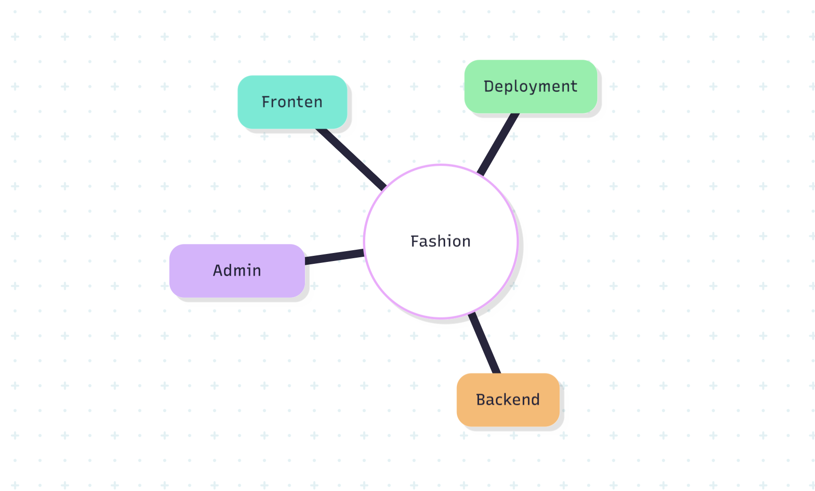
In each branch of this tree, subtrees were also provided to describe the tasks needed to be accomplished. The task for the Frontend is described in this figure below:
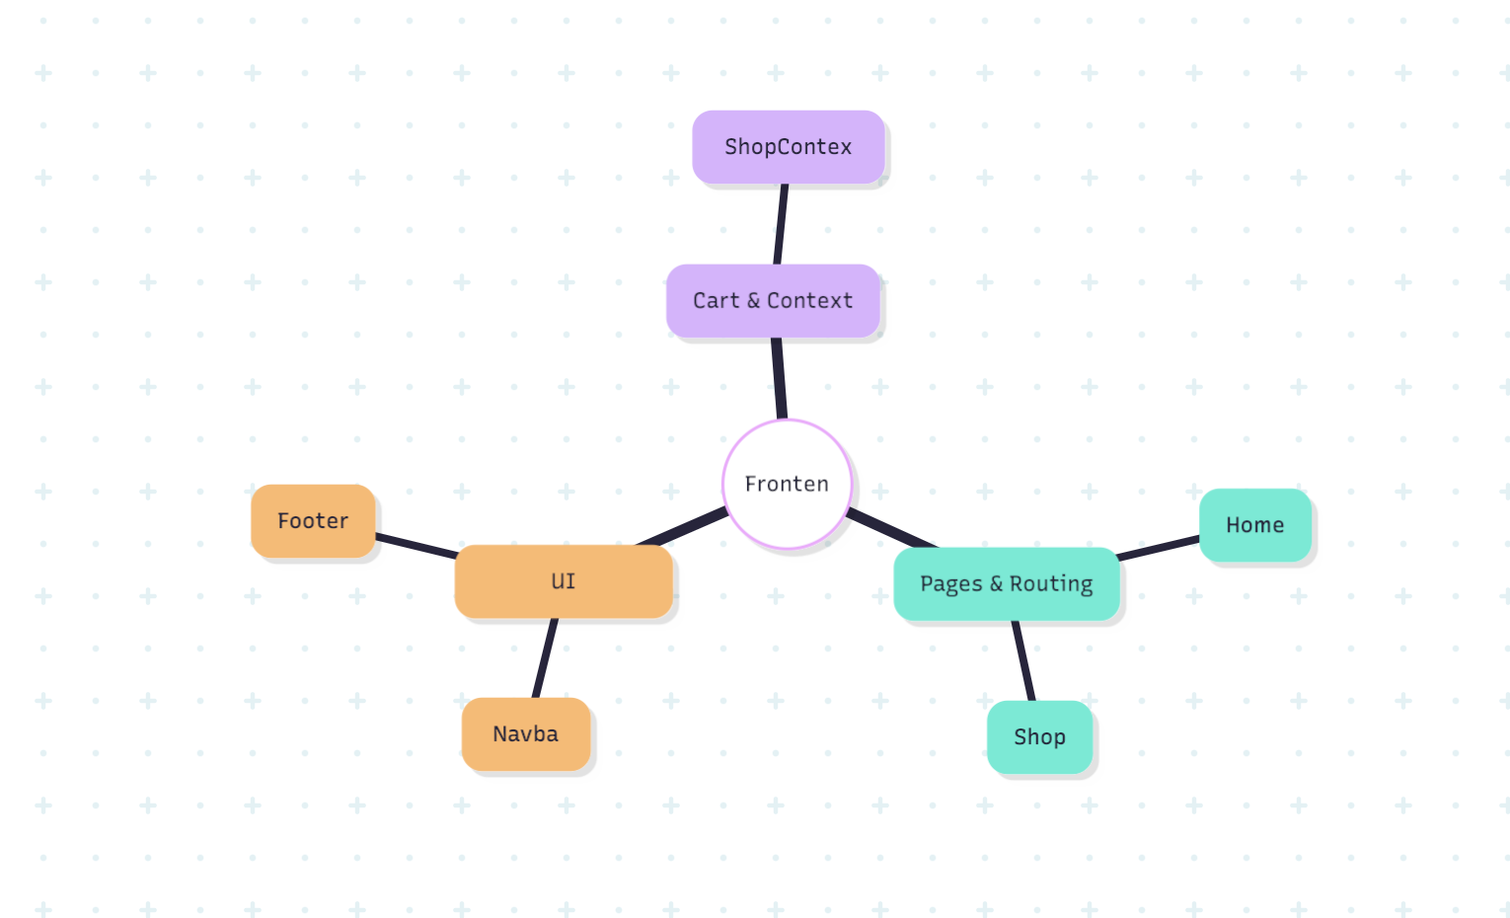

The task for the Backend is described in this figure below: 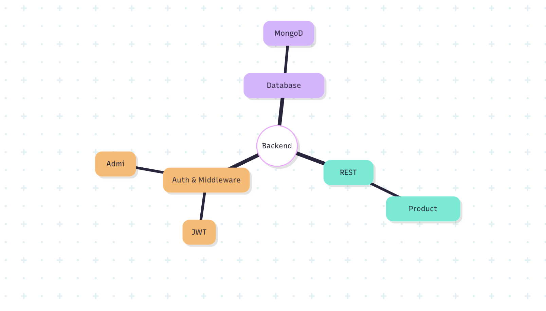
The task for the Admin Panel is described in this figure below: 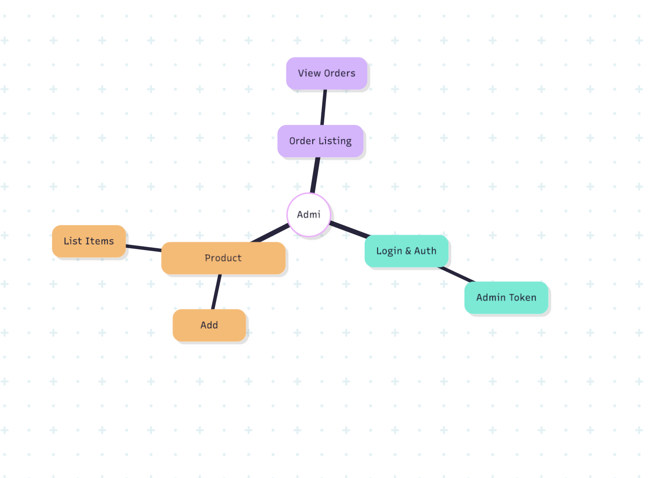
The task for Deployment is described in this figure below: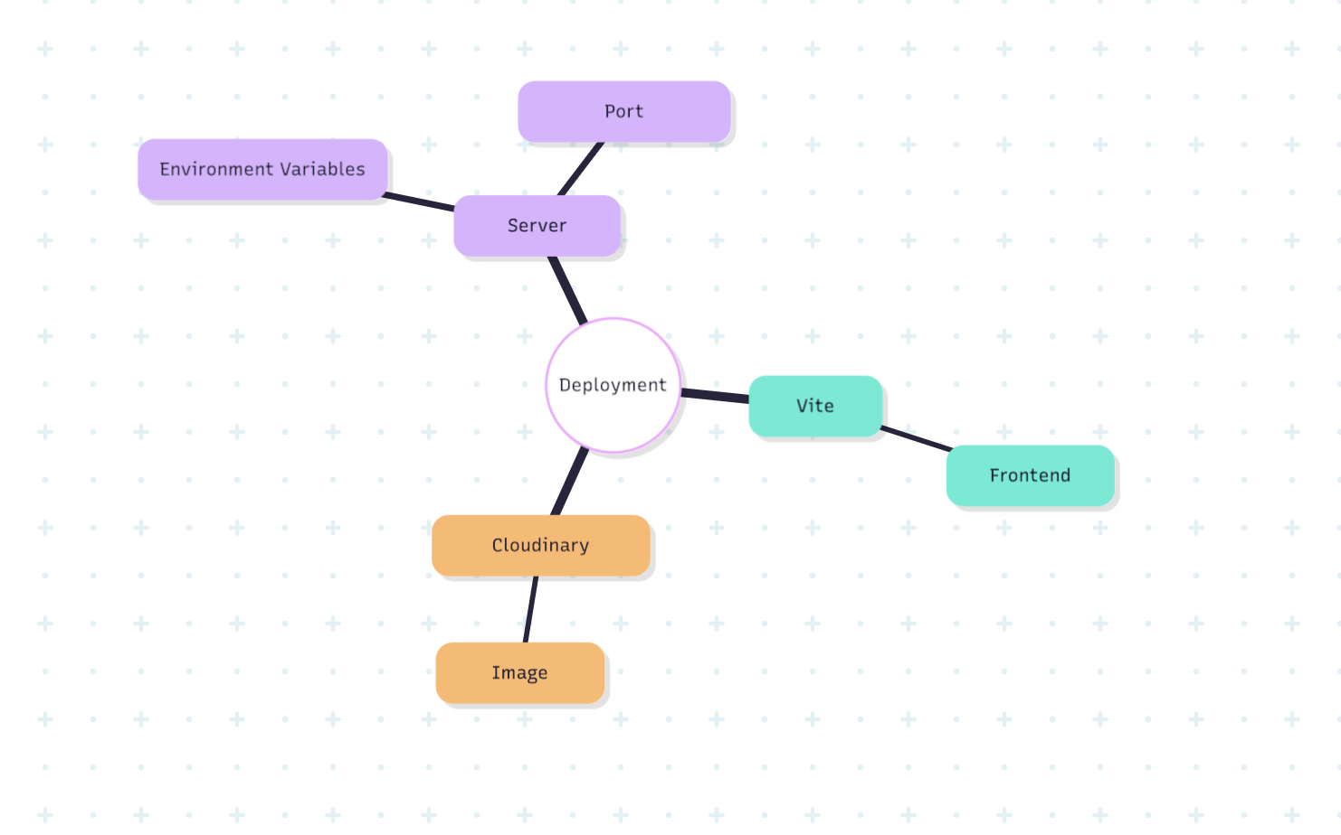
In our agile development approach, we anticipate the completion and meticulous testing of these tasks at the end of each iteration, as opposed to the traditional methodology that typically segments these steps.
- DEVELOPMENT ENVIRONMENT

The development process utilized various technologies and frameworks, structured around a full-stack JavaScript architecture.
- Front End: Utilizing React.js with Vite for building fast, responsive UI components, alongside Tailwind CSS for styling and React Router for client-side navigation.
- Back End: Implementing Node.js with Express.js to handle server-side logic, API routing, and middleware management.
- Database: Employing MongoDB with Mongoose ODM for flexible, document-based data storage and management.
- Authentication: Using JSON Web Tokens (JWT) to secure user sessions and protect admin routes.
- File Storage: Integrating Cloudinary for cloud-based image uploading and storage of product assets.
- API Communication: Using Axios for seamless HTTP requests between the frontend, admin panel, and backend REST API.
- Architecture: Following a three-tier architecture separating the customer-facing frontend, admin panel, and backend API into independent layers.
- Package Management: Using npm to manage dependencies across all three project layers — frontend, admin, and backend.
- Version Control: Managing code with GitHub to track changes and collaborate. (https://github.com/ducduy45/E-commerce-Project)
- Communication: Using Discord for team meetings and discussions.
- Task Management: Keeping track of work with Google Sheets.

- REQUIREMENT ANALYSIS AND DESIGN
- REQUIREMENT ANALYSIS
- FUNCTIONAL REQUIREMENTS
- NON-FUNCTIONAL REQUIREMENTS
- Usability requirements:
- It is essential to ensure that all pages and features of the fashion website — including product browsing, cart management, and checkout — function correctly and efficiently across all devices.
- The backend server must maintain a stable connection to both the MongoDB database and Cloudinary storage to effectively handle all incoming requests without interruption.
- User authentication must be consistently enforced, ensuring that protected routes such as order placement and admin operations are only accessible to verified and authorized users.
- The admin panel must provide a reliable interface for managing product listings, allowing administrators to add, view, and remove items without encountering system errors.
- An administrator should be appointed to regularly update product inventory, monitor server performance, and address any API or database errors in a timely manner.
- The website must be responsive and accessible, delivering a consistent and user-friendly experience across desktop, tablet, and mobile screen sizes.
- All form inputs, including login, registration, and order forms, must include proper validation to prevent incorrect data from being submitted to the system.
- Usability requirements:
• The interface should be well-organized, visually clean, and easy to navigate across all pages including the shop, cart, and checkout.
• Clear product information, category filters, and size selections should guide users toward purchasing decisions without confusion.
• Intuitive layout and familiar e-commerce patterns help users browse collections, manage their cart, and place orders with minimal learning curve.
• Users should be able to complete key actions — such as searching for products, adding to cart, and checking out — effortlessly and without errors.
• Responsive design ensures a consistent and comfortable experience across both desktop and mobile devices.
• Informative feedback, such as toast notifications for cart updates or login errors, keeps users informed of their actions at all times.
- User-friendliness requirements:
• Provide a clean and intuitive shopping interface that allows users to browse, filter, and purchase products without requiring prior technical knowledge.
• The navigation system should be clearly structured, enabling users to seamlessly move between the Home, Collection, About, and Contact pages with minimal effort.
• Product filtering and search functionality should be straightforward, allowing users to sort and discover items by category, subcategory, and size with ease.
• The cart and checkout flow should be simple and transparent, displaying item quantities, subtotals, and delivery fees clearly at every step.
• Responsiveness of the interface is an essential component, ensuring a consistent and comfortable experience across desktop, tablet, and mobile devices.
• Error feedback such as toast notifications should be displayed promptly to inform users of actions like failed logins, missing size selections, or successful updates.
• The admin panel should be designed for ease of use, enabling administrators to add, view, and manage products and orders without confusion.
- Maintainability requirements:
• The system should be designed for continuous updates and modifications. Since users may have limited insight into the platform's inner workings, the development team should build a codebase that is clean, modular, and straightforward for both end-users and maintenance personnel to work with.
• The admin panel should include intuitive functions allowing authorized personnel to easily add, update, and remove products, manage product images via Cloudinary, and oversee order listings without requiring direct database access.
• The source code must be well-structured and organized across clearly separated layers — frontend, admin, and backend — with each component, route, and controller serving a single, identifiable purpose to facilitate future updates or troubleshooting.
• The React codebase should make use of reusable components and a centralized context provider (ShopContext) so that changes to shared logic such as cart management, product fetching, or authentication need only be made in one place.
• The database architecture using MongoDB and Mongoose should have clearly defined schemas for products and users, providing a stable and predictable foundation for maintenance tasks and future scalability.
• Environment variables should be used consistently across all three layers to manage sensitive configurations such as API keys, database URIs, and JWT secrets, ensuring the system can be safely maintained and updated across different environments.
- Interface requirements:
• The user interface must be intuitive, allowing customers to easily browse collections, filter products, and complete purchases without friction.
• The interface should be fully responsive, adapting seamlessly across desktop, tablet, and mobile screen sizes to suit all user devices.
• Navigation must be consistent and clear, with a persistent navbar providing quick access to the shop, cart, login, and search functionality at all times.
• The admin panel interface must be distinct and protected, offering straightforward controls for adding, listing, and managing products without technical complexity.
• Visual feedback such as toast notifications should be present to inform users of successful actions, errors, or important updates throughout their interaction.

- DESIGN
- ERD DIAGRAM

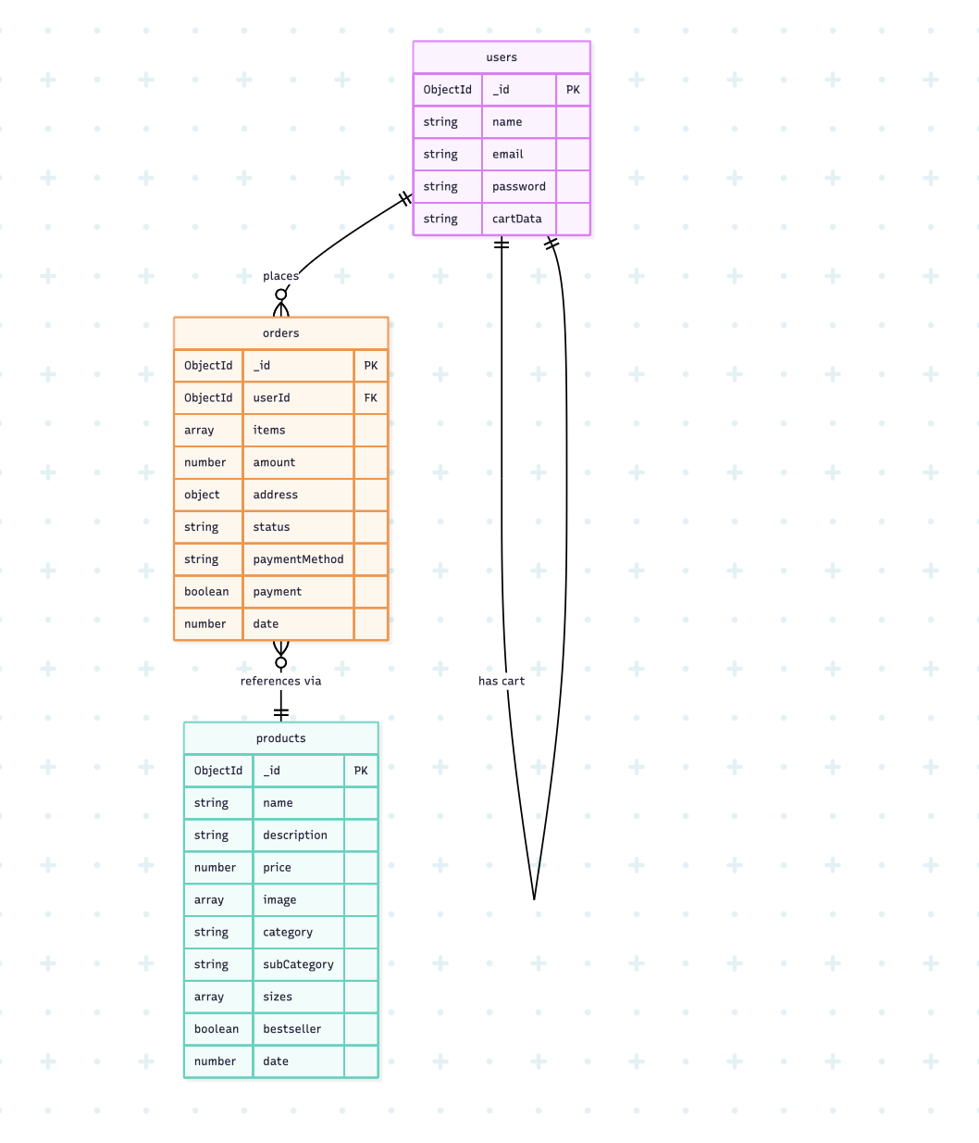
- CLASS-DIAGRAM
- FRONT-END
- BACK-END
- LOGIC FLOW OF BACKEND API
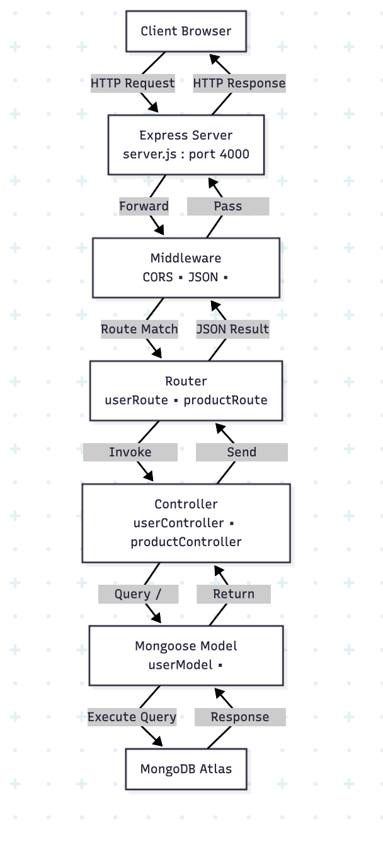
- USER CASE DIAGRAM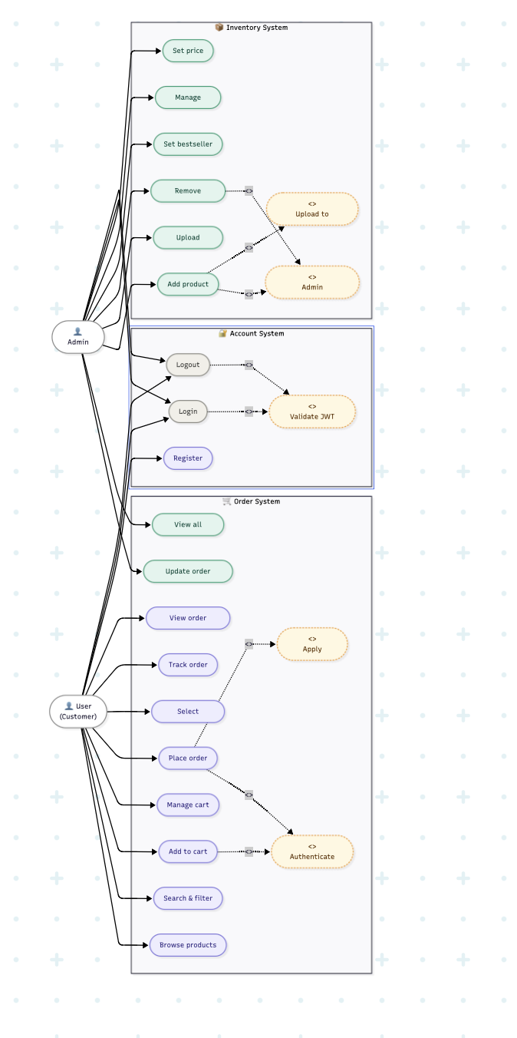
- FRONT-END

Customer-facing pages
- / : Homepage displaying hero banner, latest collection, and bestsellers.
- /collection : Page displaying all available fashion products with filtering and sorting.
- /product/:id : Detail page for a single product with images, size selection, and add-to-cart.
- /cart : Cart page showing selected items, quantities, and total price.
- /place-order : Checkout page where customers fill in delivery details and payment method.
- /orders : Page for customers to view the status of their placed orders.
- /about : Page displaying information about the store and its mission.
- /contact : Contact page for customer inquiries.
Authentication pages
- /login : Login and registration page for users to sign in or create a new account.
Admin panel pages
- /admin : Admin login page for entering admin credentials.
- /admin/add : Page for admin to add a new product with images, category, sizes, and price.
- /admin/list : Page for admin to view and manage all listed products.
- /admin/orders : Page for admin to view and manage all customer orders.

- BACK-END
Server
- Built with Node.js and Express.js, running on port 4000
- Entry point is server.js, which initializes the app, connects to the database, and registers all routes
Database
- MongoDB Atlas connected via Mongoose ODM
- Connection configured in config/mongodb.js
Models
- userModel.js — defines the user schema with fields: name, email, password, and cartData
- productModel.js — defines the product schema with fields: name, description, price, image (array), category, subCategory, sizes (array), bestseller, and date
Controllers
- userController.js — handles user registration, login, and admin login logic with JWT token generation
- productController.js — handles adding products, listing all products, removing products, and fetching single product details
Routes
- userRoute.js — maps endpoints for /register, /login, and /admin
- productRoute.js — maps endpoints for /add, /remove, /list, and /single
Middleware
- adminAuth.js — verifies the admin JWT token to protect admin-only routes
- multer.js — handles multipart form data for product image uploads
Third-party Integrations
- cloudinary.js — configures Cloudinary for cloud-based image storage, used when adding new products
- dotenv — manages environment variables such as MongoDB URI, JWT secret, and Cloudinary credentials
API Structure
- All user endpoints are prefixed with /api/user
- All product endpoints are prefixed with /api/product
- CORS is enabled globally to allow cross-origin requests from the frontend and admin panel
- IMPLEMENTATION
1. Project Setup
- Initialized three separate environments: frontend, admin panel, and backend
- Configured Vite as the build tool for both frontend and admin React apps
- Set up environment variables using .env for backend URL and admin credentials
2. Backend Development
- Built a REST API using Node.js and Express.js
- Connected to MongoDB Atlas using Mongoose for database management
- Integrated Cloudinary for cloud-based product image storage
- Implemented Multer middleware for handling multi-image file uploads
- Created product and user data models with Mongoose schemas
3. Authentication
- Implemented user registration and login using JWT (JSON Web Tokens)
- Built a separate admin authentication middleware to protect admin-only routes
- Stored user tokens in localStorage for session persistence on the frontend
4. Frontend Development
- Built reusable UI components including Navbar, Footer, Hero, and ProductItem
- Created a global shopping context using React Context API to manage cart state, product data, and user session
- Developed pages for Home, Collection, Product detail, Cart, Place Order, Login, and Orders
- Integrated Axios for all API communication between frontend and backend
5. Admin Panel Development
- Built a protected admin dashboard with login authentication
- Implemented product management features: add new products with image upload, list all products, and delete items
- Connected admin panel to the same backend API using Axios
6. Testing & Deployment
- Tested all API endpoints for user authentication and product management
- Built the frontend for production using Vite's build command
- Configured CORS to allow communication between frontend, admin panel, and backend across different ports
- DISCUSSION AND CONCLUSION
Discussion
Developing a full-stack fashion e-commerce web application presented significant challenges, particularly in handling user authentication, product data management, and ensuring seamless communication between the frontend, admin panel, and backend. React and Vite provided a solid foundation for the frontend, ensuring a responsive and intuitive user interface across all device sizes. Meanwhile, the backend built with Node.js and Express required careful structuring to manage product listings, cart logic, and order processing efficiently. This involved configuring REST API endpoints, implementing JWT-based authentication for both regular users and admin access, and integrating Cloudinary for reliable cloud-based image storage and retrieval.
One of the more demanding aspects of the project was synchronizing the shopping cart state across the application using React Context, ensuring that cart data remained consistent as users browsed, added items, and proceeded to checkout. Additionally, building a protected admin panel with separate authentication middleware required a thorough understanding of token validation and route protection strategies.
Conclusion
This project was a comprehensive learning experience that greatly enhanced our understanding of full-stack web development using the MERN stack. We gained practical knowledge in designing RESTful APIs, managing database schemas with Mongoose and MongoDB, and building dynamic frontend interfaces with React. Integrating third-party services such as Cloudinary deepened our ability to leverage cloud solutions within a real-world application. Tackling challenges like JWT authentication, multi-image product uploads, and global state management reinforced the importance of clean architecture and data integrity in modern web applications. Overall, this project strengthened our technical skills across both frontend and backend development and has well prepared us for future challenges in building scalable, production-ready web applications.

- REFERENCES
1. FRONT END
- https://react.dev/
- https://vitejs.dev/guide/
- https://tailwindcss.com/docs
- https://reactrouter.com/en/main
- https://www.npmjs.com/package/react-toastify
2. BACK END
- https://nodejs.org/en
- https://www.npmjs.com/package/
- https://mongoosejs.com/docs/
3. DATABASE
- https://www.mongodb.com/docs/atlas/
4. FILE STORAGE
- https://cloudinary.com/documentation
5. TOOLS & ENVIRONMENT
- https://www.npmjs.com/
- https://axios-http.com/docs/intro
- https://code.visualstudio.com/

